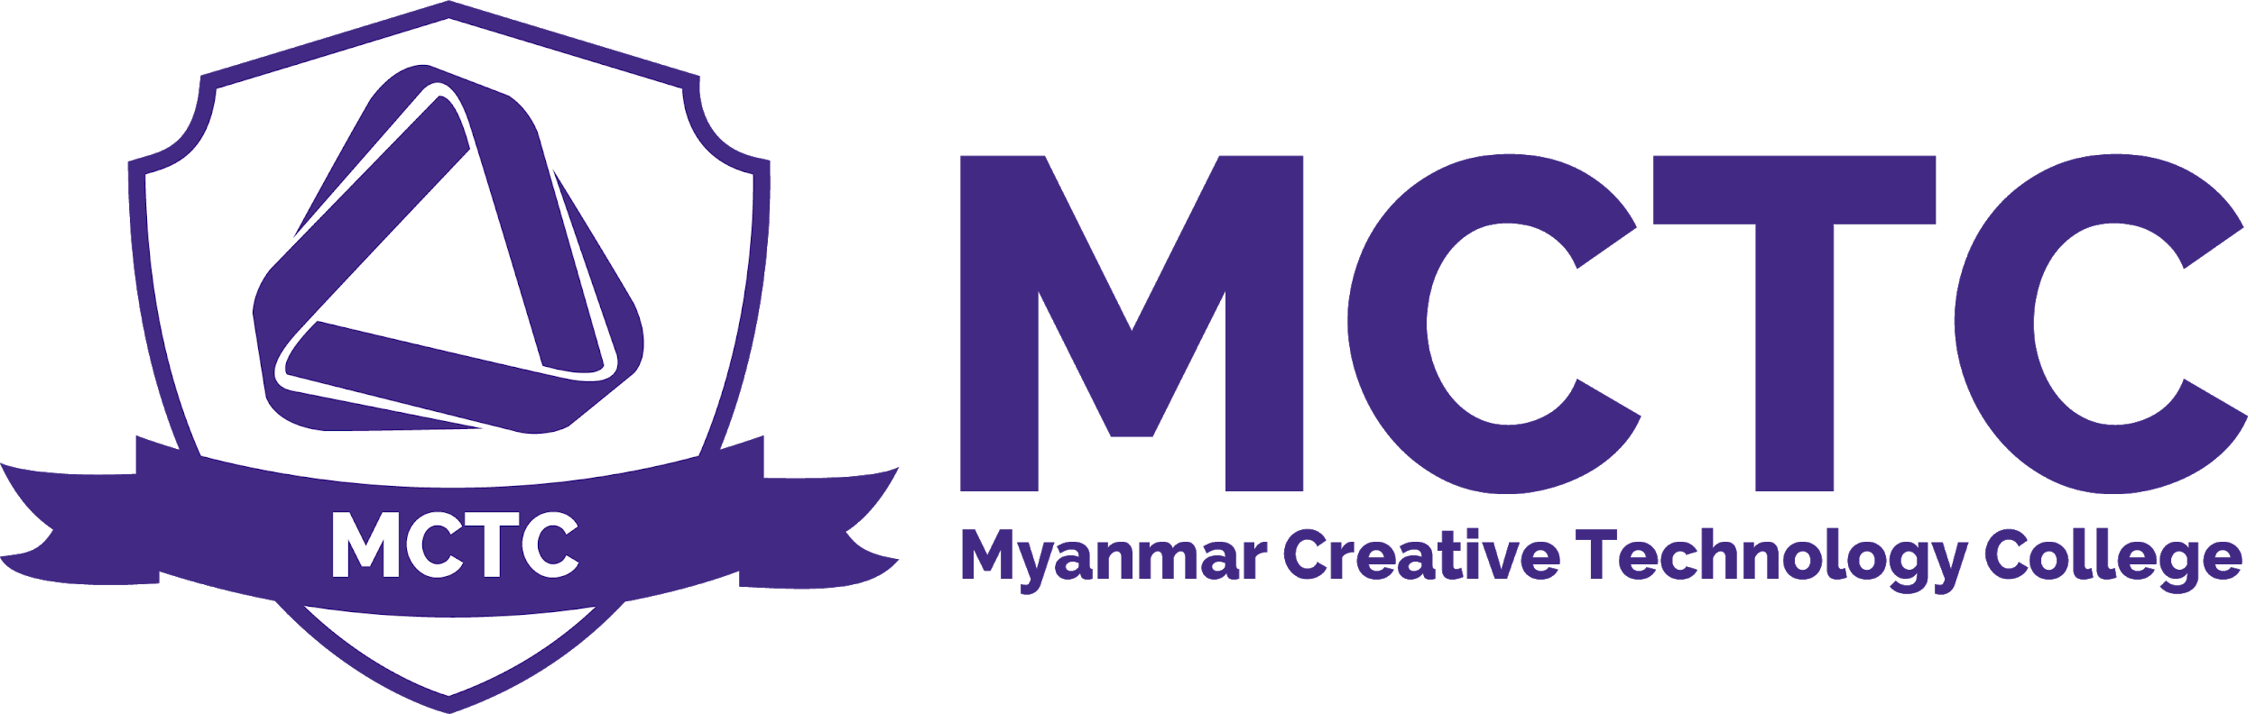

Risk Assessment , Health and Safety Policy
Version: 1.0

Definition and Purpose

Myanmar Creative Technology College’s strategy is to give the highest priority to safeguarding the health and safety of employees, learners, contractors and any member of the public who may be affected by its operations. The policy identifies responsibilities and describes the organisation and the arrangements for implementation. Risks are inherent in everyday life. This policy aim to identify risks and to adopt systems for minimising them

Scope
MCTC Management , BTEC Management , Academic Board , Students

Policy

Risk Assessment Procedure

Management and Administrative team of MCTC carefully evaluate of what, in the workplace, could cause harm to people; to facilitate an evaluation of any precautions in place and whether further preventative measures are required.

Risk assessment is a pro-active process by which:
- Hazards are identified;
- The risks associated with the hazard are evaluated;
- Appropriate methods to eliminate or control the hazard evaluated.

Health and Safety Policy

Myanmar Creative Technology College is committed to ensuring, so far as is reasonably practicable, that all activities are carried out with the highest regard for the health, safety and welfare of all its employees, students and of any others who may be affected by its undertakings.

Our aim is excellence in health and safety, by means of continuous improvement of standards, systematically removing the causes of accidents/incidents and ill-health.

We are committed to:
- Providing a safe and healthy working and learning environment
- Preventing accidents and work related ill health
- Assessing and controlling risks from curriculum and non-curriculum work activities
- Ensuring safe working methods and providing safe equipment
- Providing effective information, instruction and training
- Monitoring and reviewing systems to make sure they are effective
- Promoting a positive health and safety culture through communication and consultation with employees, students and their representatives on health and safety matters
- Setting targets and objectives to develop a culture of continuous improvement
- Ensuring adequate welfare facilities exist at the college
- Ensuring adequate resources are made available for health and safety issues, so far as is reasonably practicable
In a medical emergency, MCTC may authorize a qualified medical examination or emergency treatment for the student, as may be necessary. The College will contact student’s parents or legal guardian to obtain further authorization when time and situation permits.

Contractors
MCTC have contractors for many of facilities maintenance , technical and safety procedures. All Contractors must work along following rules.
- Adhere to all college policies and procedures
- Follow college site safety rules at all times.
- Permits to work will be issued by the Facilities Manager.
- Any equipment used on college premises must be in safe working condition and have up to date PAT testing.
- When working on college premises they must ensure that the work area is cordoned off and signed appropriately.
- All contractors must report to Facilities Manager before work is commenced
- Any defects or health and safety issues must be reported to the Facilities Manager immediately.
- Any accidents on college premises must be reported to the Facilities Manager.
- Contractors must be made aware that smoking is only permitted in the designated smoking area.

Emergency Toll Free Numbers
- Police : 999
- Fire:998
- Nearest Fire Station: 41st Police and Fire Station (1 km) , Phone Number :09510999
- Nearest Fire Station: Sule Fire Station (2 km) , 998:1

Risk Assessment , Health and Safety Policy

Person Responsible | CEO , Student Service ,Programme Leader , Academic Head
Approval Date
Version Number | 1.0
Approved by | CEO
Date of next formal review
Status

