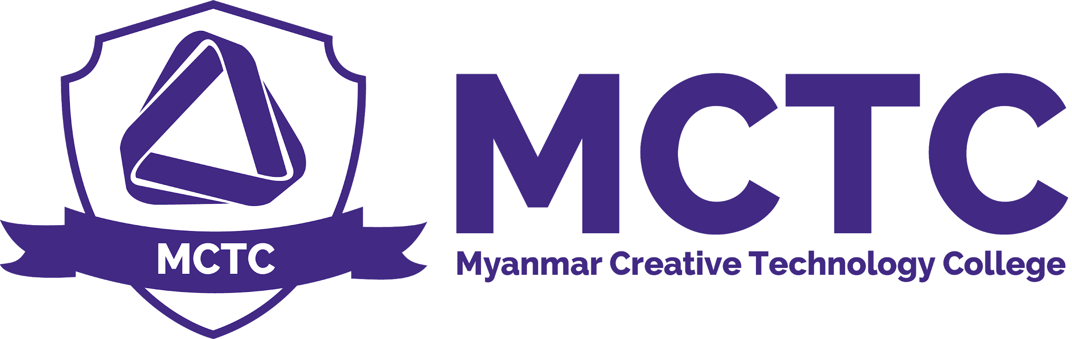

Assessment Policy
Version: 1.0

Purpose
Assessment policy aims to outline the guidance around assessment brief, assessment decisions, internal verification process and breach of academic regulations.

Assessment Policy aims to ensure that academic standards are appropriate and consistent across course teams and reflect agreed assessment policies and assessment criteria, and that the assessment outcomes for students are fair and reliable.

Scope
BTEC Management , Academic Board , Students

Definition

Following are component of assessment policies.
Assessment item: a piece of assessed work, e.g. an art, project, assignment or video footage; assessment items should be valid, reliable and authentic

Assessment brief: guidance provided for students on how to complete a specific item of assessment, to include information about the nature of the task, the format for presentation, and assessment criteria, and, if used, the marking scheme

Assessment criteria: specifies the quality of student work required to successfully complete the assessment item and indicates how particular grades may be achieved.

Formative assessment: Formative assessment is any task or activity which creates feedback (or feedforward) for students about their learning. It has a developmental purpose and does not carry a grade which is subsequently used for summative purposes.

Summative assessment: Summative assessment is any assessment that contributes to the final grade/mark of a module or course to provide a measure of student achievement in relation to the learning outcomes and assessment criteria.

Grading: describe in broad terms the typical performance required to achieve a particular band of marks; Myanmar Creative Technology College publishes generic grading for HND course work to be used by academic teams as a reference point or benchmark in establishing assessment criteria

Approval of assessment: a process involving both internal and external scrutiny to assure assessment items and assessment criteria are appropriate in terms of academic level, and learning outcomes are valid, reliable and authentic and that there is broad equivalence for students across modules/units

Moderation of marking: a process to assure assessment criteria, and thus academic standards, have been applied consistently and that assessment outcomes are fair and reliable

Internal Verification: a process of professional engagement by College staff to demonstrate that the grades awarded are accurate, appropriate and consistent to ensure parity of standards

Pearson/External Verification: a process of objective engagement by experienced academic peers (external examiners), independent of the College, to ensure that the level of achievement of students reflects the required academic standards and is comparable to similar programmes provided by the relevant awarding body

Internal Verifier: Undertakes internal verification, covering all Assessors and all units, in line with the internal verification plan.

Policy
Assessment is through a series of assignments including research modules, hands-on practical exercises and group projects. Units are interlinked to replicate “real world” scenarios and offer the opportunity for students to build a range of skills to maximise employment opportunities.

All assessments in Myanmar Creative technology college are based on the following principles

- Authenticity: All assessment activity must have processes in place to ensure that the achievement is the student’s own work.
- Validity: The method of assessment and the evidence provided must be appropriate and capable of demonstrating the achievement of learning outcomes and related assessment criteria of the provision at the appropriate level.
- Reliability and consistency: The assessment decisions must be reliable and consistent. The assessment decisions are reliable in that they indicate the achievement of learning outcomes. The assessment decisions are consistent regardless of when the assessment occurs or who does the marking.
- Fitness for purpose: Assessment must be fit for the students and their learning.

Assessment Modes
1.Assignment | Assignment is primary assessment method for MCTC’s BTEC courses. Students must satisfy learning outcome in the assignment paper for every unit. After that assessors give the grading according to the assessment criteria of each unit.  Judging from each unit requirement , assignments will be required to present by combining  - Literature - Words  - Art - Digitally Drawn Art  - Screen-capture - Evidence and Explanation of Work
2.Tutorial | Tutorial is mainly to keep in check of student progress in learning at MCTC. In most of the case , tutorial is followed after practical/field trip sessions to make sure student gets the purpose of Practical/Field Trips
3.Presentation | Student are required to present about their ideas and Artwork , working procedure ,explanation and concept behind the artwork in front of accessors and classmates.

Internal Verification Process
Internal verification, or quality assurance of assessment, is part of an overall quality system at Myanmar Creative Technology College
- Internal verification process has two components. One focuses on internal verification/review of assessment brief whilst the other is concerned with accuracy and consistency of the assessors’ judgements on student work.
- Internal verifier must ensure that every learner’s work is internally verified at least once during the course of study. Please refers to IV Sampling Plan.
- Records of the internal verification activities for assessment decisions must be maintained and made available to the Chief Internal Verifiers or Head of Quality Assurance.
Internal Verification of Assessment Form

Assignment Brief , Assessment Briefs and Assessment Criteria
Students must be provided with written assessment guidelines describing the nature of the task, the format for presentation and the assessment criteria for all items of assessment. This is to provides clear information for students on what they are expected to do, how they are expected to go about it and how their work will be marked.

Assessment briefs should include:
- Assessment criteria - The basis upon which the quality of a student’s work will be graded
- Any specific constraints or requirements - e.g. word limits, and the need for good academic practice, e.g. referencing of sources
- Grading
- Submission procedures and deadlines, and the consequences of late, incomplete or non-submission

Assignment Submission

Assignments are to be submitted on or before stipulated dates. Failure to do so without prior authorisation will result in non- acceptance of the assignment in that term and a ‘Referred’ status will be recorded in the results.

Use of Assessment Forms

All assessors must use assessment form of MCTC. Available here
MCTC_Assessment Form

Request , Appeal and Extenuating of Assignment
Extenuating/Mitigating Circumstances are circumstances which are unexpected, significantly disruptive and beyond the control of students that affect their ability to meet an assessment deadline or affect performance in assessment.

Grading System
Marks | Grade
80% and Above | Distinction
65% – 79.99% | Credit
50% to 64.99% | Pass
44-49% (Refer)/Below 30% (Remodule) | 44-49% (Refer)/Below 30% (Remodule)

Feedback to Students and Return of Student Assessments
In normal circumstances, assessment items should be marked and returned to students with feedback within 2-4 weeks of the date of submission. Where, for valid reasons, this cannot be achieved, the member of staff concerned should consult with the course/programme leader and where appropriate their line manager; agree an alternative date, and inform the students affected of the revised date of return. In such circumstances, it may be desirable to provide students with feedback in advance of the return of the assessment item and determination of the provisional grade.

Staff should enter grades for marked coursework assessment items onto the necessary forms (IV , Assessments and feedback form) as soon as possible after the work for the whole group has been marked. Students must be advised all grades for assessment items remain provisional until confirmed by the Academic Assessment Panel and therefore a provisional ‘fail’ grade can be turned into a ‘pass’ grade or vice versa. In the case of MCTC, all marks are provisional, and subject to the scrutiny of the College.

Effective and timely feedback (i.e. commentary on performance identifying strengths and ways in which improvements could be made with an emphasis on feedforward) should be given to students for all formative and summative assessments.

Confirmation of assessment decisions

There is a two-stage process for considering the assessment taken by a student in any given year or other defined period of study.

Stage 1 : involves a meeting of the Academic Assessment Board after every term to review the results for the modules taken and to confirm recommendations regarding the grade achieved by each student.

Stage 2 : involves the Assessment Board meeting once a year who review the student’s entire profile of module results, confirm progression or award recommendations and, if appropriate, the classification of each student.

Assessment Board normally meet at the end of the academic year.

Release of assessment results
Results of all unit assessment will be released after being finalized by the assessment Board and after internal verification processes. Certification will take place 3 months after the last unit assessment.Academic Department is responsible for the publication of official results to students following the meeting of Academic Assessment Panel. Publication of results will be made electronically via the secure student portal. It is the student’s responsibility to ascertain his or her results.

Re-assessment
Re assessment links usually open a day after the academic assessment panel has taken place.
if a student is referred or misses on some of the ‘Pass’ criteria in a submission, he/she has to re-submit again using the same assignment brief covering the missing criteria during the resubmission time. A student who undertakes such a reassessment will have their mark capped at a bare “pass” unless there is a valid EC claim. When a student has failed both the original assessment and the reassessment for a module, the student shall normally be entitled to retake the module on one occasion.
Usually , re-submission period for student is 2 weeks (14 days)
Certificate & transcript of assessment results
The official certificate and transcript will be issued by Myanmar Creative Technology College when received from Pearson. The MCTC Graduation ceremony will take place in December every year. MCTC will claim partial certification for any students who have successfully completed any units on the programme.

Misconduct
Academic misconduct covers a range of offences which collectively can be described as cheating. The following is not an exhaustive list and the College reserves the right to include any other type of cheating under the terms of this policy:

- Plagiarism by copying and passing off, as the student’s own, the whole or part(s) of another person’s work, thereby not properly acknowledging the original source. This particularly 5 relates to material downloaded from the Internet or copied from books, journals or magazines

- Collusion by working collaboratively with other learners to produce work that is submitted as individual learner work done by another learner as their own including work paid for from professional sources

- Impersonating another candidate in an examination, introducing unauthorised materials into the exam room, unauthorised communication during tutorial , presentation.

- Falsely claiming extenuating circumstances to gain an unfair advantage in assessment outcomes

Reporting alleged Malpractice
If the assessor suspects any student with a possible breach of assessment regulations including assessment malpractice , assessor must inform assessment board and program leader. If an arguable case exists, the Programme Leader, or nominee, invites the relevant student for an assessment malpractice meeting. The penalty will be proposed by the Programme Leader, or nominee.

Assessment Policy

Person Responsible | Academic Head , Internal Verifier , Programme Leader , Quality Nominee, Assessors
Approval Date
Version Number | 1.0
Approved by | Academic Head
Date of next formal review
Status

